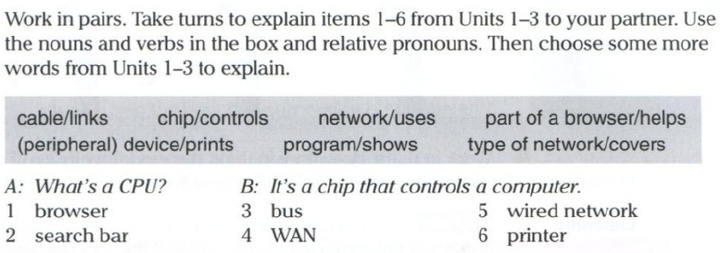

1. | A: What’s a browser? | B: It’s a program that shows web pages
2. | A: What’s a search bar? | B: It’s a part of a browser that helps to find things into a web page
3. | A: What’s a bus? | B: It’s a cable that links diferents components into PC
4. | A: What’s a WAN? | B: It’s a type of network that covers a wide area
5. | A: What’s a wired network? | B: It’s a network that uses wires
6. | A: What’s a printer? | B: It’s a device that prints what we send to do it

Juan Carlos Francisco Mesa.
2º DAW Semi A

